http://www.travelmozo.com

Introduction
We are setting up a new Travel portal which will be developed using Drupal 7.

This portal will be a complete travel portal with travel guides, articles, hotel reviews, forums and much more.
It is dynamic portal and we will keep adding new features as it grows. There is no end date of this project.

Examples of similar sites
http://www.virtualtourist.com/
http://www.tripadvisor.com/
http://www.lonelyplanet.com/
http://www.travelpod.co.uk/ - Nice Design
http://strayoutdoors.com/
http://www.afropolitan.co.za/travel/246-afro-travel-kenya-the-jewel-of-east-africa
http://www.raveable.com/il/metropolis/summers-riverview-mansion-bed-and-breakfast/i305678
http://www.roughguides.com
http://www.worldtravelguide.net/

Work
We don’t want providers to upload content, we want only a structure in place, we will upload content by ourselves.

http://www.lonelyplanet.com/ is the best website for example; we want to show most of the features from this site

Work style
We need to work together. Provider should be online on skype and whenever any feature is implemented he should let me know so that I can test on fly and provide any feedback immediately.
TravelMozo Main features
- Content
- Forums
- Shop
- Advertisement
- phpList
- Affiliate Integration – Expedia/others

TravelMozo Content Types
- Destinations
- Attractions
- Articles
- Things To Do
- Forum
- Shop
- Basic Page

Work to be done

Error
http://www.travelmozo.com/forums/cheap-hotel-bangkok
Notice: Undefined index: hs_lineages in hs_taxonomy_field_formatter_view() (line 402 of /home/travelmo/public_html/sites/all/modules/hierarchical_select/modules/hs_taxonomy.module).

http://www.travelmozo.com/ Slideshow
  - Hide the node when there is no slideshow image attached to that node

Gmap
- Show the gmap inside the node on the right side of location
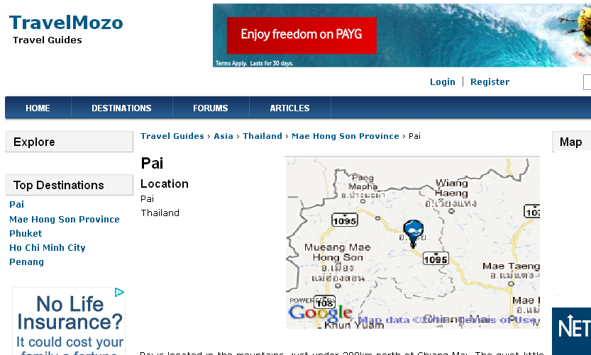

- Instead of Drupal marker us yellow colour marker
- Make gmap to be a link to open in popup window (pref.) or in a new window

Forum
- Forum Blocks
    - On the destination/attractions/etc… nodes show the forums topics from the respective place’s forum
E.g.
On http://www.travelmozo.com/bangkok/attractions/little-arabia-bangkok show the topics from Bangkok forum only - http://www.travelmozo.com/forums/asia/thailand/bangkok

    - When there is no post in the forum then don’t show the block

Photo Gallery
- We need a photo album and photo gallery module to be installed/configured/customized. This module will allow users to upload photos, allow photos to be organized into galleries.
    - User shall be able to upload photos. But make them to create a Gallery first, each photo should be in a gallery.
    - Show Image Alt tag, Tags and description field to each photo.
    - For gallery the fields needed would be tags, description
    - Allow them to make a photo to be the gallery main image
- Gallery display
    - On a gallery page show all the galleries in grid.
    - On a photo page show the photo on the top and the rest of photos in the gallery at the bottom
    - Each gallery/photo should have it’s own url
E,g,
travelmozo.com/london-photo-gallery
travelmozo.com/london-photo-gallery/big-ben
    - On each photo page show the rating, thumbs up thumbs down, overall rating – only registered/logged in users hall be able to rate.

Review module
- We need a way to allow user to review various type of contents. This module should allow user to review and rate various type of content such as Destination, Attractions, Hotels etc.
- We need this module to be flexible to allow having various criteria for the reviews. E.g. for hotels we want following criteria
    - Services
    - Price
- We should be able to add new parameters from the admin
See some examples of such reviews
http://www.lonelyplanet.com/spain/barcelona/restaurants
    - http://www.lonelyplanet.com/spain/barcelona/restaurants/cafe-3/cafe-zurich

User
- User Registration
    - Places visited
      - Show one box to add places visited
      - Allow to add move boxes + to enter more places visited
      - Allow places to show up in these boxes when users type the place. May be using Location module or something?
- Fields
    - Add user profile photo
    - Show profile photo in user’s page
- Top Users (by points)
    - Show a block in 5x4 grid with user profile pictures.
    - Show top users by points (using points module)

Articles
- http://www.travelmozo.com/articles
    - Show the review, rating, thumbs up on the right side

Shop
- This will be linked to Amazon. Have to work out how to do it best.
- We will add all items from amazon manually and also link so it should be easy. When user clicks on the buy now it will go to the Amazon shop.
- Few modules
    - http://drupal.org/project/amazon
Or
    - http://drupal.org/project/amazon_store - This module doesn’t work

Points system
- 10 points for adding new article
- 5 points for reviews for any content type
- 3 points for any forum post
- 2 points for comments
- 5 points when all the fields in user profile are filled

Site Performance
Improve site performance for faster page loading.

